How to use the GCPL free resources:
Click on eBooks
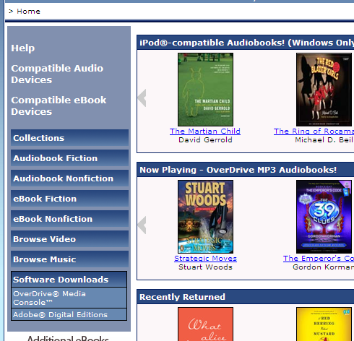

Above are the selections one can download. They have drop down menus when you click on them.
You will need to download a program or app to be able to view your selection.
There are clear directions on this site to do so. (Where the Compatible Audio Device or Compatible eBook Devices are located in the blue menu) What you need to download depends upon the device. This is the best place to start.
You will also have to have an account with the GCPL. This is free to all Gwinnett County residents and easy to obtain.
GCPL adds content regularly so check back often.

